CS5551 Advanced Software Engineering

**Problem Set 4 (PS-4)**

**Deadline: April 3 (T)**

Submit a hard copy of your solutions to the instructor during the class

**Name**: Cameron L'Ecuyer

**Class ID**: 17

You are supposed to develop a simple desktop phone book application. It includes a text-based interface that allows the user to add name/phone pairs and search for phone by name. The data persist in a text file. The application’s architecture is based on the popular Model-View-Controller (MVC) architectural design pattern; the Model is responsible for data processing and persistence, the View is responsible for the user interface (presentation and collection of user input), and the Controller is responsible for executing actions according to user input and current state of the application and all communications between the three components. These include both generic behavior at the abstract interfaces level and application specific behavior at the concrete classes level, as we demonstrate next.

1. Draw the Phone Book GUI.
2. Draw the Phone Book application UML class diagram; it includes three interfaces and three concrete classes that implement them, plus another class, PhoneBookGUIView, which extends PhoneBookView
3. The SetState includes three methods: setState() (cold/monitoring), stateHasChanged() (hot/execution), and changeView() (cold/monitoring). Explain how a MVC pattern is specified in the SetState design.

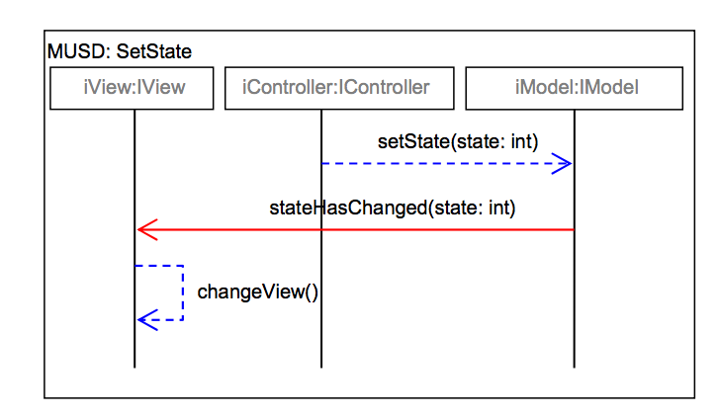

1. The application specific inter-object behavior of the Phone Book is specified in the UserInput MUSD. It specifies that whenever the controller’s userHasInput() method is called by the viewer, and the input is not empty, one of several alternative scenarios should happen, depending on the current state of the application and the input . For example, if the current state is STATE IDLE and the input is COMMAND QUIT STRING (defined as “quit”), the controller should call the model’s saveAll() method and then call its setState() method with the new state STATE EXIT as argument. Complete the following diagram for the UserInput MUSD.

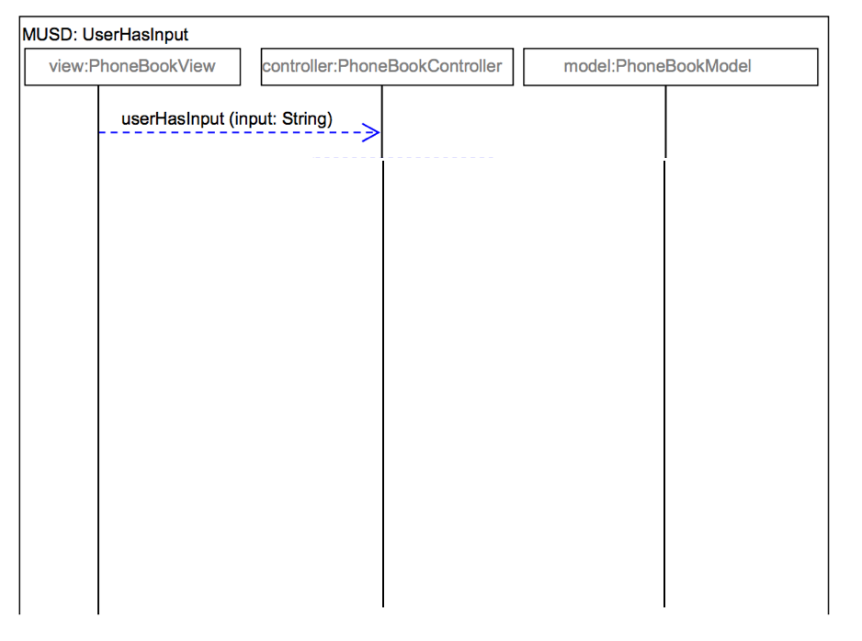

1. Describe the advantages and disadvantages of the MVC pattern in the application specific inter-object behavior of the Phone Book.

Answers:

1.

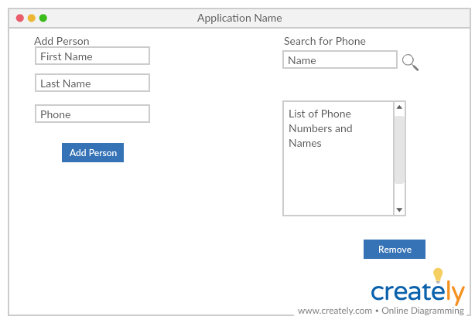

2.

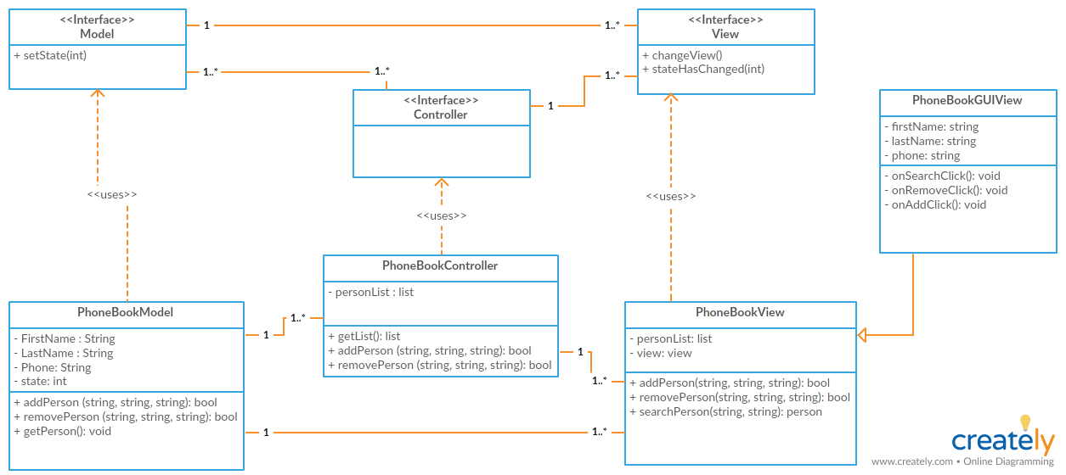

3. The controller calls setState in model when it detects a change from the view, the model then begins updating the data and the state, and then calls the view's stateHasChanged to trigger an update to the view with changeView. The specification comes from the separation into a three-tiered architecture using the MVC pattern, if everything was in one tier, there would not be the need to have multiple functions to change the state.

4.

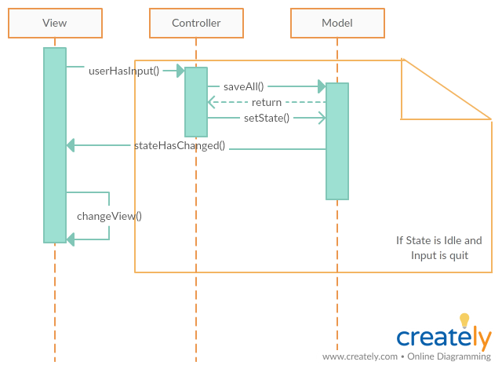

5. One primary advantage is that it allows for separation of concerns, which will allow changes to one part of the MVC without breaking the other parts. It also allows a whole part of the MVC to be swapped out with a different piece (i.e. a new controller) without affecting the application. However, a disadvantage maybe that the pattern could be high levels of complexity for a simple application. Another disadvantage may be the space and memory overhead needed for such a small application.